**Report 2**

Members: Floyd R, Fei Xu, Minh Truong

The landscape and noise map we are going to combine are:

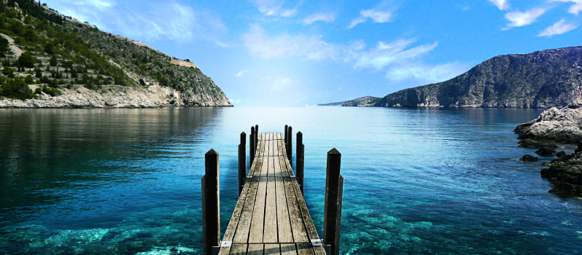 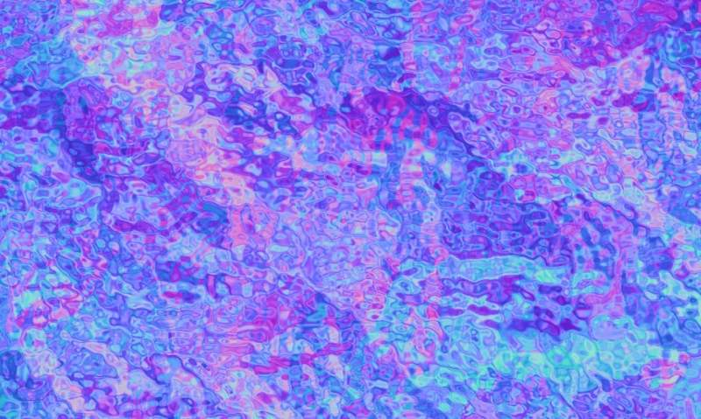

landscape noise map

We use every pixel on the noise map as a vector displacement. We use the color information of noise map as vector displacement as following the rule:

Red from (0-255) to receive X (-1.0, 1.0)

Green from (0-255) to receive X (-1.0, 1.0)

Blue from (0-255) to receive X (0.0, 1.0).

We use

noisevec = normalize(texture(texture_foreground, pass_TexCoord).xy)

to generate the displacement vector and scale it by

noisevec = (noisevec * 2.0 - 1.0 ) * 0.02,

since the coordinates of texture is in (0,1). By (noisevec * 2.0 - 1.0 ) it is scaled into (-1,1). Then we use a factor to control how large the displacement is.

So if we scale it as “noisevec = (noisevec * 2.0 - 1.0 ) * 0.02”, the result is:

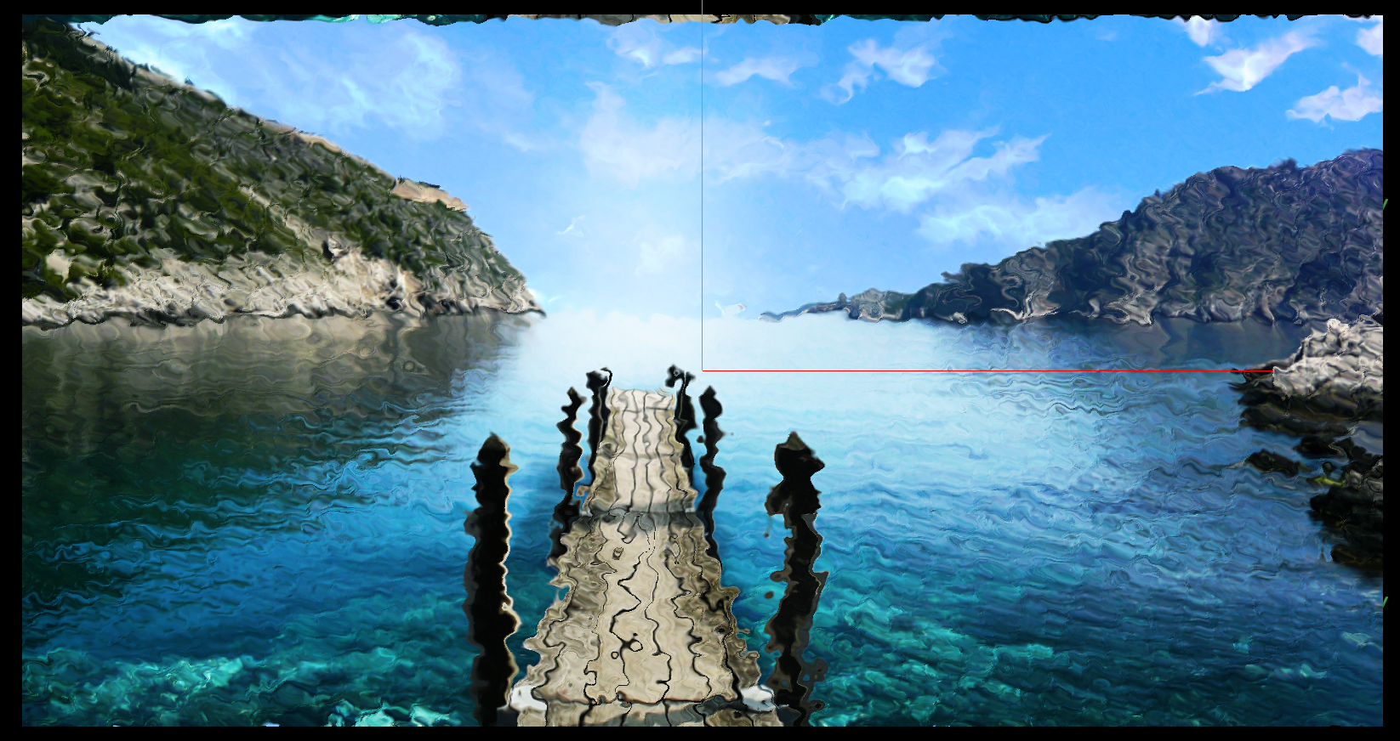

If we scale it as “noisevec = (noisevec * 2.0 - 1.0 ) * 0.2”, the result is:

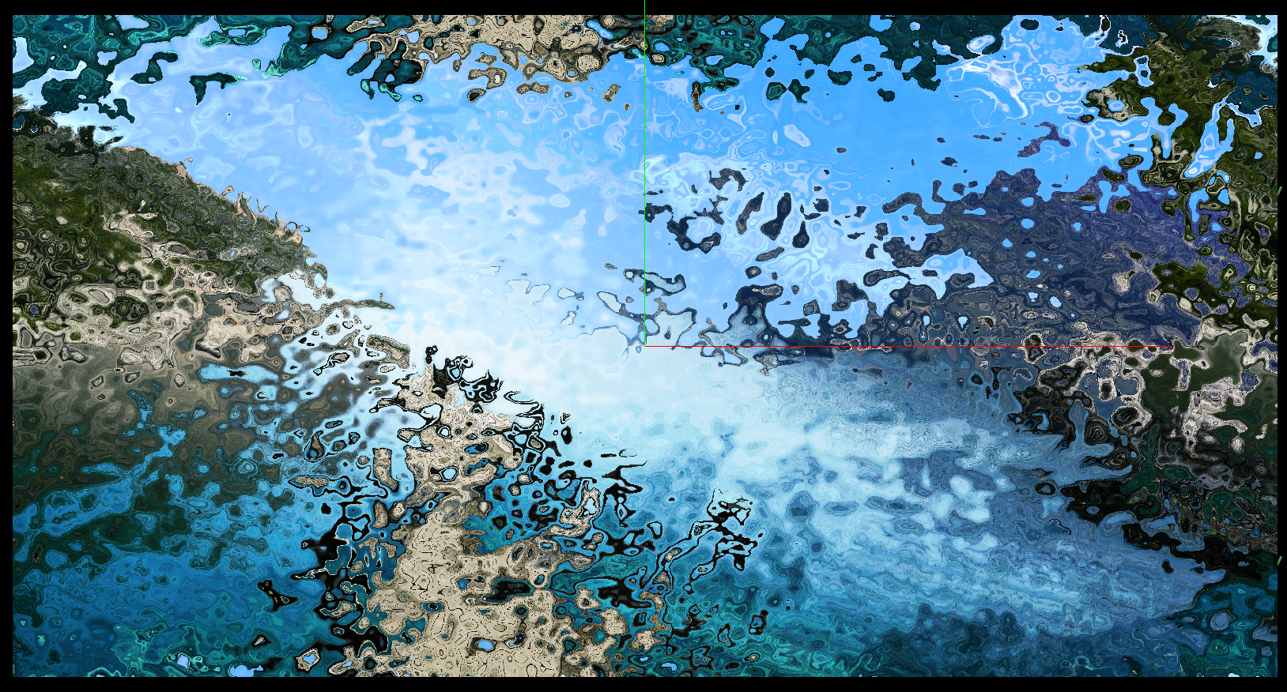

The larger value we use to scale the noisevec, we give the coordinates of texture a large displacement.